Q1. True

Q2. True

Q3. False – Maximum transmission unit

Q4. False – Works basically the other way, decrements to 0

Q5.

Step 4. On VM1, we will apply ‘netem’ rules to the private network IF to add 60ms of emulated latency and a random 5% packet loss process.

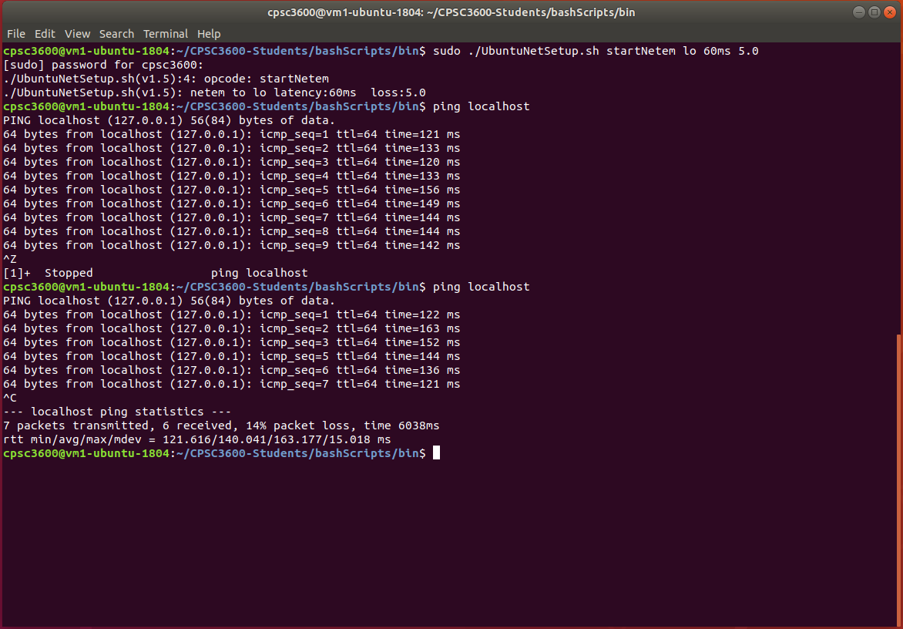

Basically, I copied this from in class. I understand it all, the packet loss was 14% but also, I stopped it after only 7 packets to be able to fit on the screen capture.

Part 1. I followed with you to get the log, but my first attempt did not show any packet loss. After trying to launch the server again using ./TCPRx I got this error:

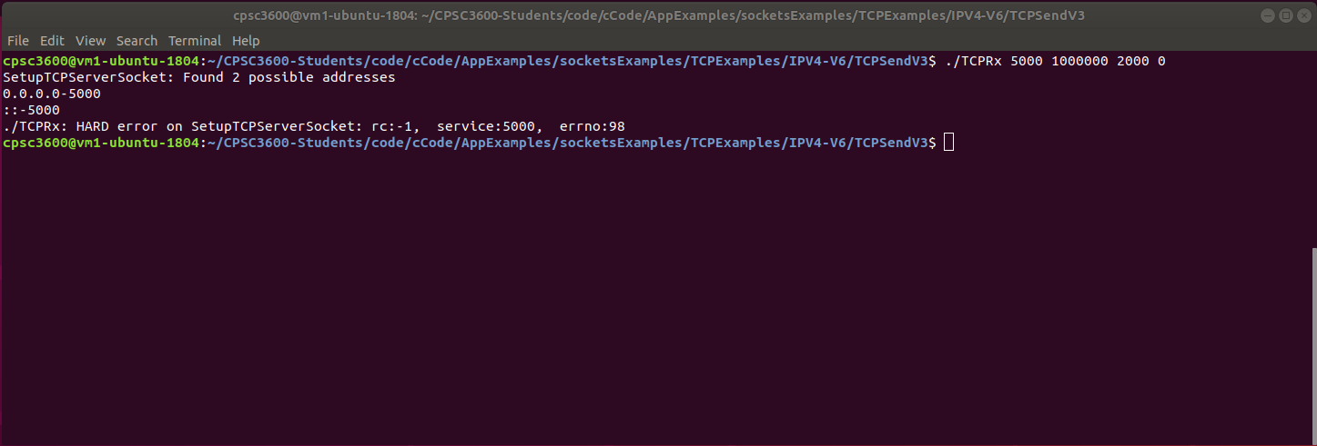

Here was my original log (no packet loss):

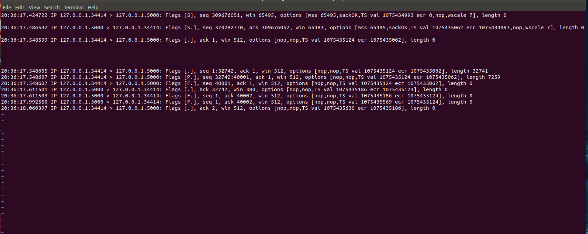

Obviously since my server could not work, I could not do Part 2. I will email you to see if there is any way for me to do this part tomorrow.